Tutorial 4

a) Business cycles - Patterns of upswing and downswing (expansion and contraction) that can be discerned in economic activity over a number of years.

b) According to classical economists, business cycles are caused by caused by exogenous factors, or bad government policy actions. Classical economists believed that the markets would self-regulate and there would be no need for invention to restore equilibrium.

c) Three different ways in which GDP can be measured:

- Expenditure method: value of the final sales

- Income method: amounts earned by the factors of production

- Production method: value added by each agent

The three methods are linked to each other because they should all yield the same answer. Income is earned by factors of production and the total value of production will be equal to the total value of income earned through wages, salaries, rent income and profits. The income is then used to spend on production in markets.

Inflation - an increase in the general price level in the economy.

Different measures of inflation:

Consumer Price Index - measures the general level of prices that consumers have to pay for goods and services, including consumption taxes. It includes imports that are consumed by households but excludes exports that are (only) consumed by foreign residents. CPI is Important because it can be used to gauge the cost of living, and it affects wage negotiations, pensions, and social security payments

Producer Price Index - Tracks the selling prices received by domestic producers for their goods and services. It includes raw materials and intermediate goods. PPI is important because it is an early indicator of inflationary pressures, as rising production costs often lead to higher consumer prices. It is a good predictor of where prices are going.

GDP Deflator - A measure of the level of prices for domestically produced output. It is important because it allows GDP to be compared across countries and overtime.

E) Personal Inflation - the rate of price change experienced by an individual or household based on their unique consumption habit.

Inflation deviations impact perceptions:

Individuals with higher personal inflation rates may reduce spending or demand higher wages, influencing overall economic behavior.

Question 2

1. An economic shock is an unexpected event which causes GDP to fluctuate. Economic shocks can originate from various sources, such as natural disasters, geopolitical events, financial crises, or technological innovations.
2. A drop in the global price of platinum would negatively affect South Africa’s economy as South Africa is one of the largest manufactures of platinum in the world. A drop in the global price of platinum would result in low export revenue. South Africa would earn less revenue from exporting platinum.

It could also lead to job losses, as the mining sector is a significant source of employment in South Africa. Lower prices could lead to mine closures, layoffs, and reduced investment, resulting in job losses and slower economic growth, particularly in mining-dependent regions.

C) Self-insurance - Saving by a household in order to be able to maintain its consumption when there is a temporary fall in income or need for greater expenditure.

* Self-insurance would be helpful in this situation because:

Whether self-insurance would be helpful would be determined by whether the drop in platinum was temporary or permanent, if temporary, households in mining-dependent areas faced by unemployment or reduced income due to lower platinum prices will have their personal savings helping to cover short-term needs like housing, food, and education

If permanent or prolonged, these savings may not be enough to sustain them.

d) Co-insurance - A means of pooling savings across households in order for a household to be able to maintain consumption when it experiences a temporary fall in income or the need for greater expenditure. Co-insurance involves support from social networks or government.

Co – insurance could help as families employed in the mining sector would have an opportunity to receive support in the form of subsidies, emergency funds, or unemployment benefits from social networks or the government, extending the time they can cope financially.

e) Consumption smoothing is a basic source of stabilization in an economy. It is a strategy individuals, households, or governments use to maintain a stable level of consumption over time, despite fluctuations in income or economic conditions. strategies individuals, households, or governments use to maintain a stable level of consumption over time, despite fluctuations in income or economic conditions.

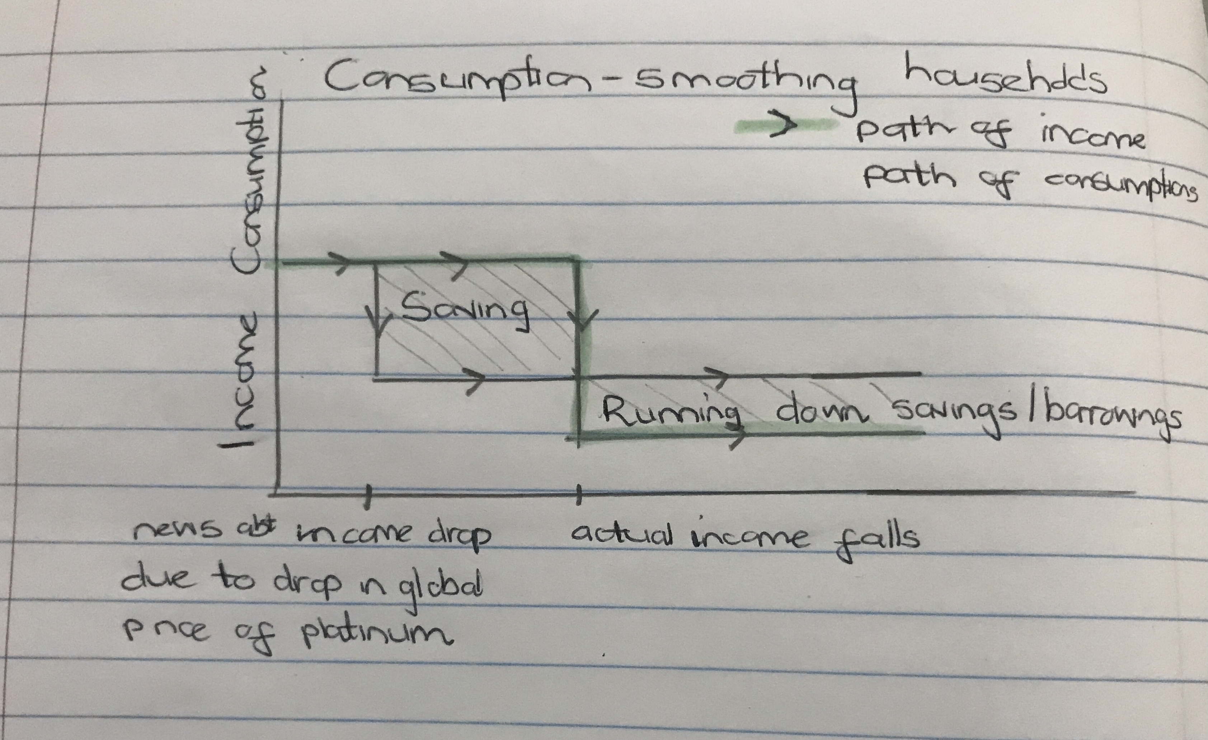

f) Assuming South Africa is a credit constrained country, households would deal with the effect of platinum price increase:

Increased Employment Opportunities: For households dependent on the mining sector, a price increase could boost employment and wages, as mining companies may expand operations to take advantage of higher prices. This would directly improve their income and consumption.

Wage increase: There might also be an increase in wages for mining workers resulting in higher incomes.

Rising Costs for Goods and Services: For households not directly benefiting from the platinum sector, the effects could be negative. There might be inflation due to higher export earnings, especially due to the limited credit in the economy. This could lead to high fuel, energy, and food prices which would erode the purchasing power, forcing households to cut back on non-essential spending.

Question 3

1. Capacity utilization rate: A measure of the extent to which a firm, industry, or entire economy is producing as much as the stock of its capital goods and current knowledge would allow
2. Nash Equilibrium: is a set of strategies, one for each player, such that each player's strategy is the best response to the strategies chosen by everyone else.
3. In an environment with high business confidence

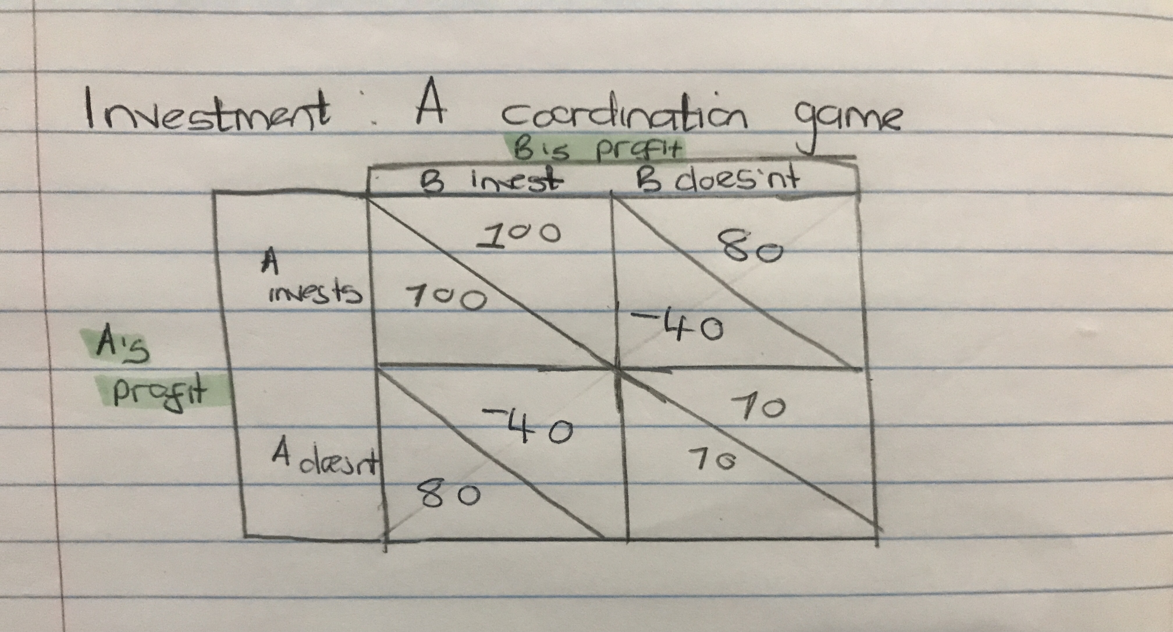

High Business Confidence suggests that firms expect the economy to grow, leading to higher demand for their products.

The Nash equilibria is when both firms invest (top-left cell), leading to 100 profits for each firm, or don’t (10 profits each). In a high-confidence environment, the payoffs for both firms are likely higher when both firms choose (top left cell) due to increased market demand and positive expectations about future profitability.

This 100 profits outcome creates a virtuous cycle where investment by both firms leads to higher demand, high- capacity utilization. The 10 profits outcome is the opposite. The best result occurs when both firms invest simultaneously, as this generates profits for both and maximizes capacity utilization.

In the payoff matrix, (top left cell) is a pareto-efficient equilibrium where both firms are better off compared to other outcomes. Since both firms prefer this outcome, they are likely to coordinate on this strategy when they are confident about economic conditions

The (top left cell) equilibrium is stable in a high-confidence environment because deviations from the top left cell would lead to lower payoffs for both firms.